Academic Session 2017-2018

How to Apply

STEP-1:

Go to our website: www.saldihacollege.com. Then click "Online Admission-17" bottom

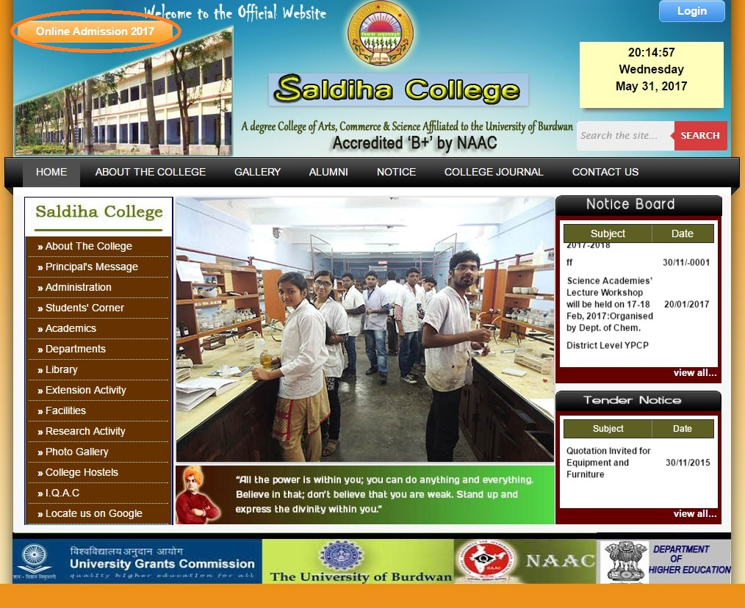
STEP-2:
Show the Notice first before Form fill-up

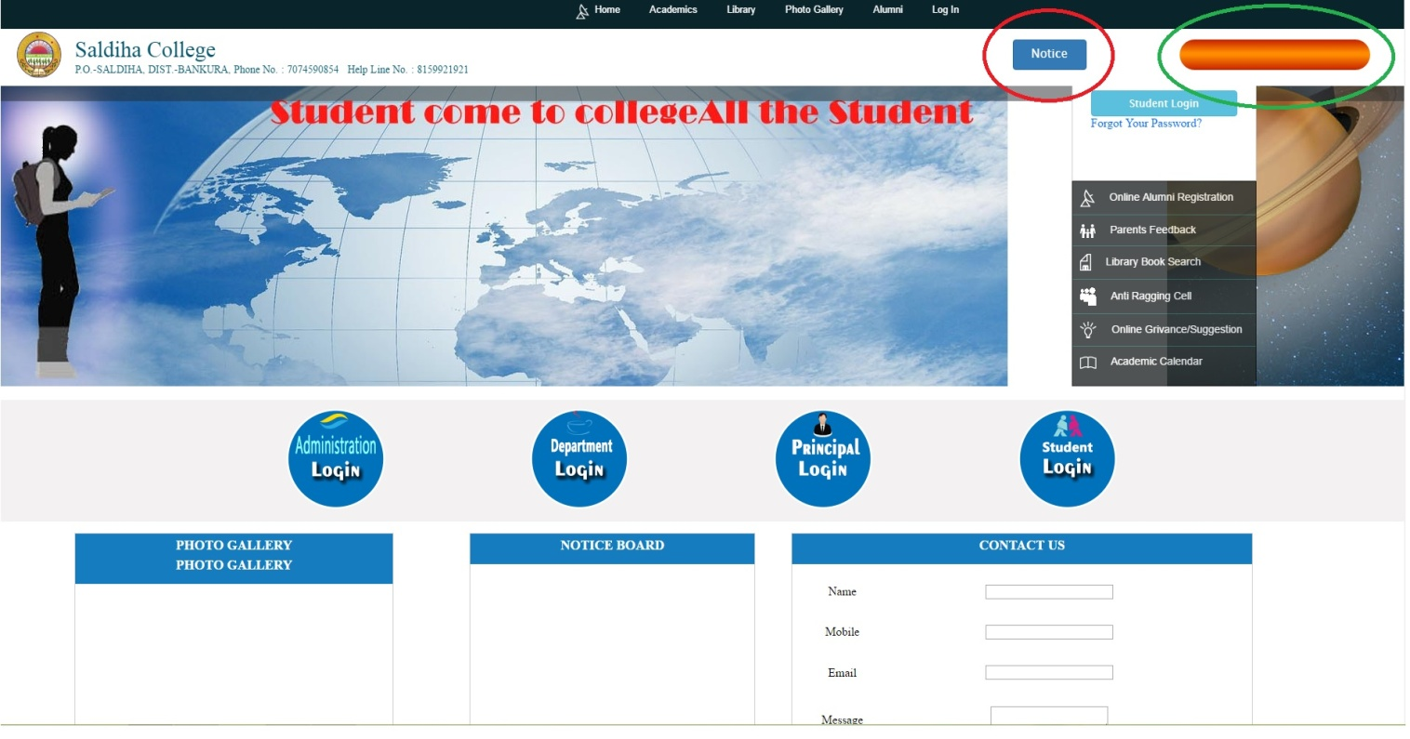
Click here for Admission Form fill-up
STEP-3: Fill-up all the requisite portion of the form carefully.
Read the term & Condition before fill-up
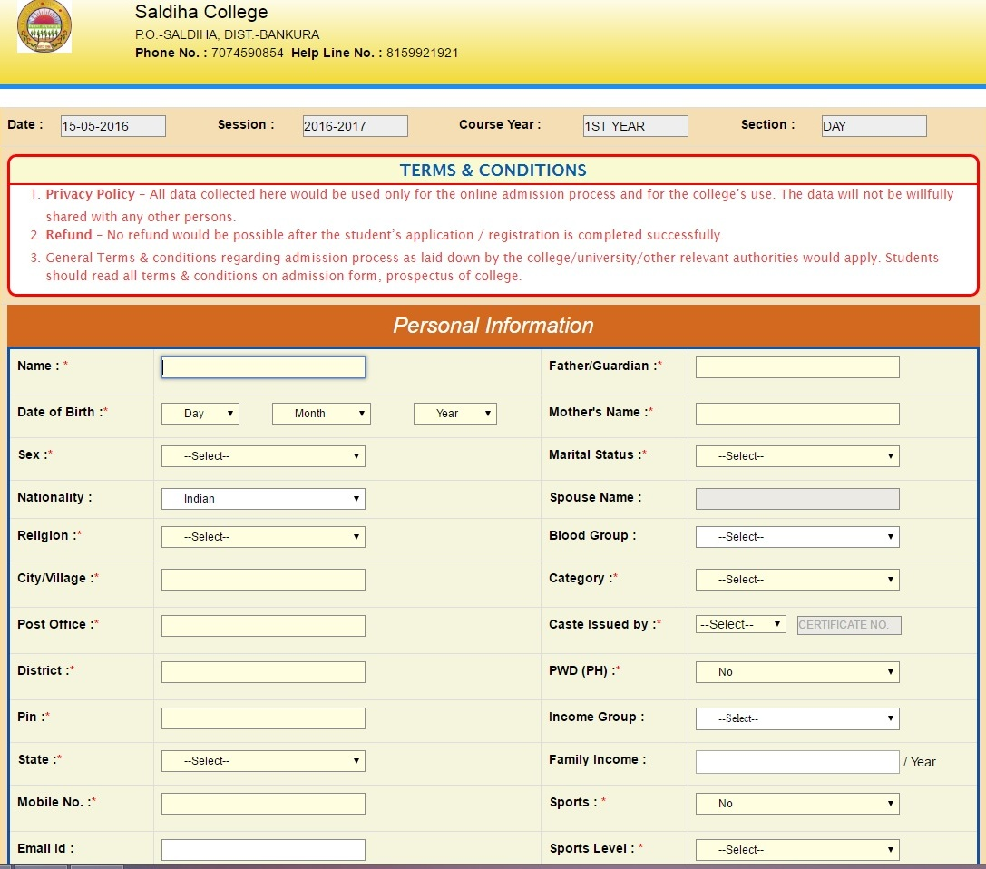
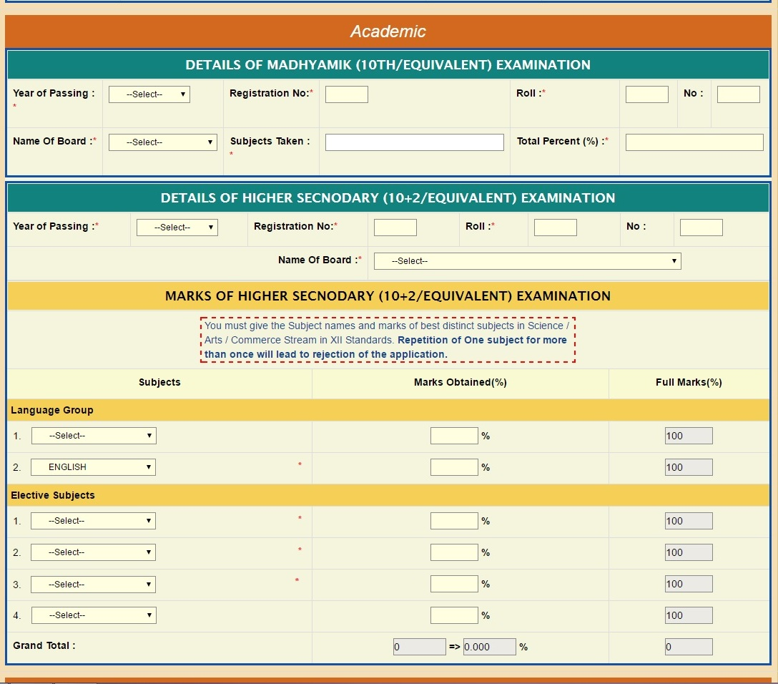
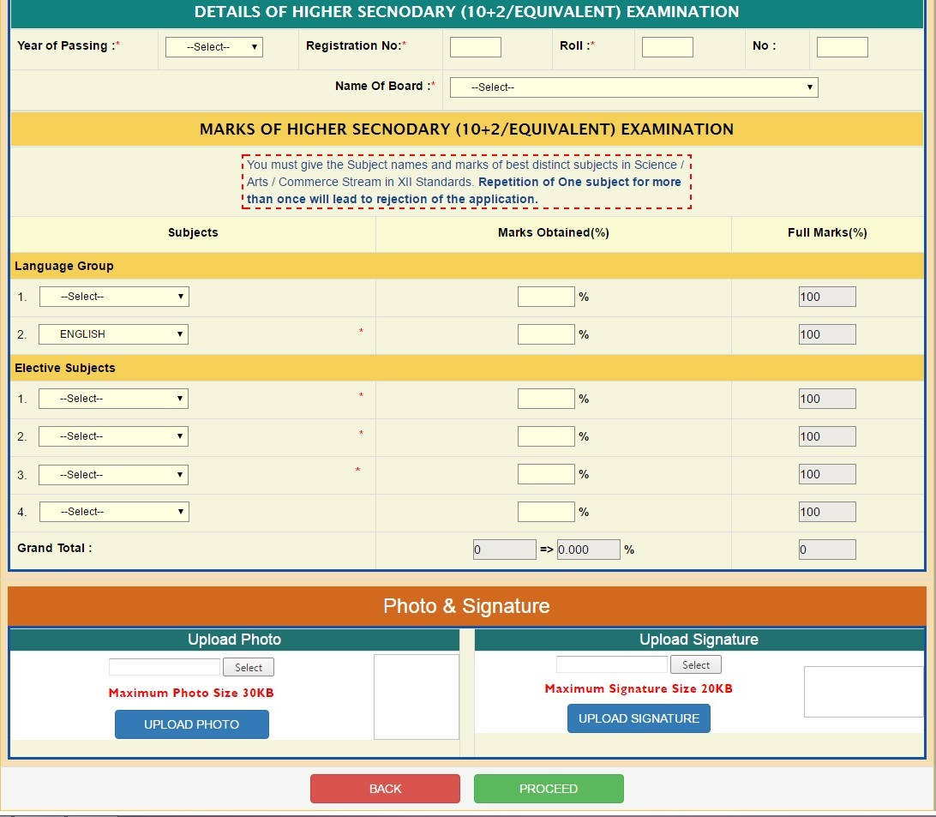
After completion click the proceed bottom
Select/Browse Scan Signature ≤ 20 KB and then Upload
Select/Browse Scan Photo ≤ 30 KB and then Upload
STEP-4: Check the filled-up form carefully

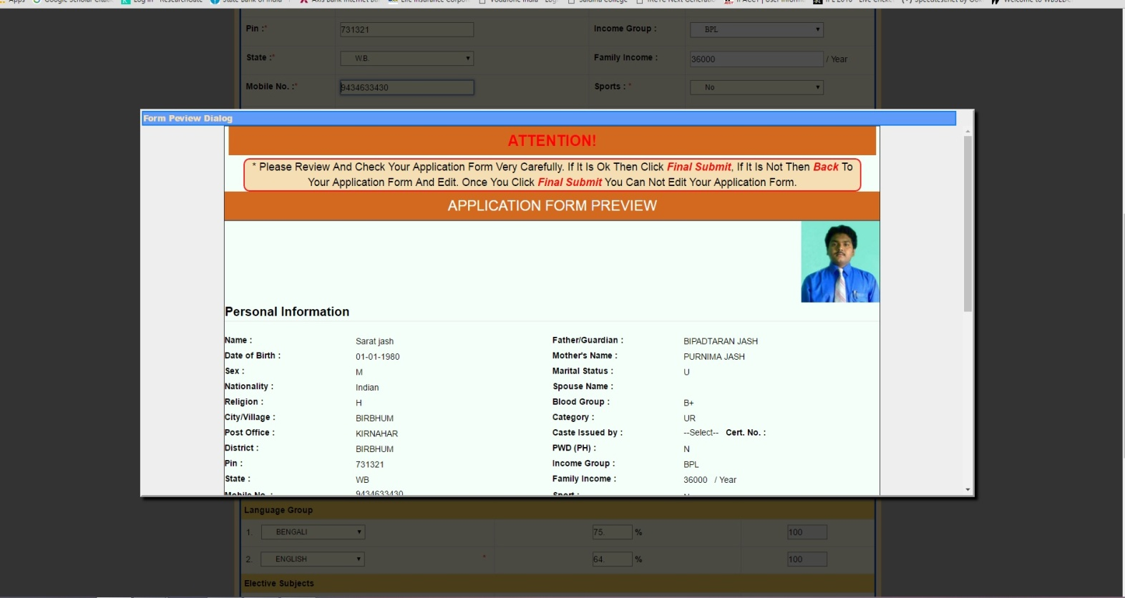
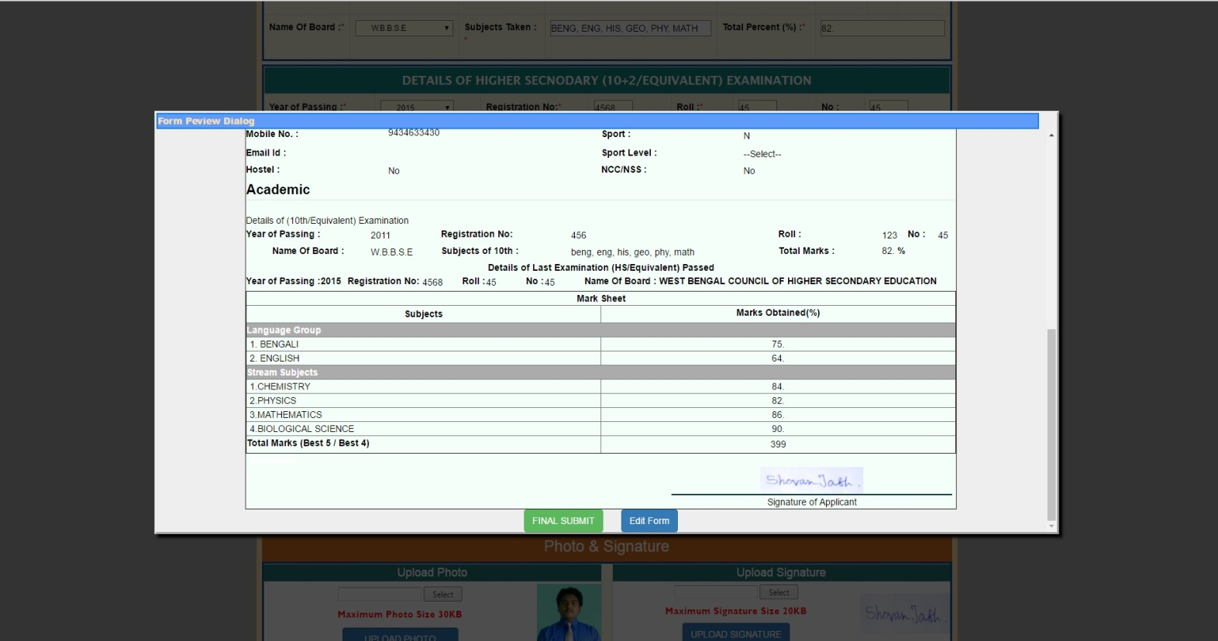
If you want to change/correction any data click Edit Form......After edition then submit the form finally.
If all the data are correct then click FINAL SUBMIT

STEP-5:
Appear the following option box. See the Red mark note.
You can choose Honours, General, or Honours & General course in three way.........
1. If you apply for Honours only then click "Apply for Honours" & "Not Apply for General"
2. If you apply for General only then click "Not Apply for Honours" & select any two General Apply options (if applicable).
3. If you apply for both Honours & General then click "Apply for Honours" & select any two General Apply options (if applicable).
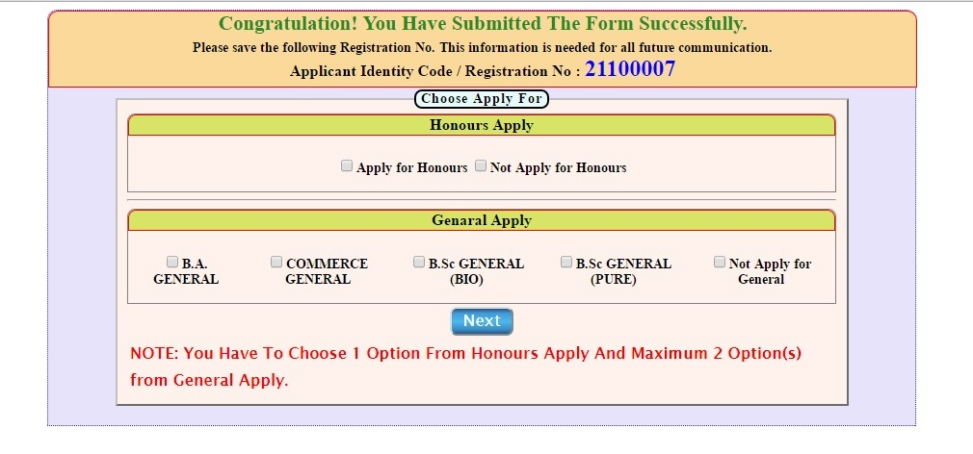
After select the options, then click NEXT

Appear the Honours subjects choice box (if Apply for Hons./ Hons.+Gen. both)
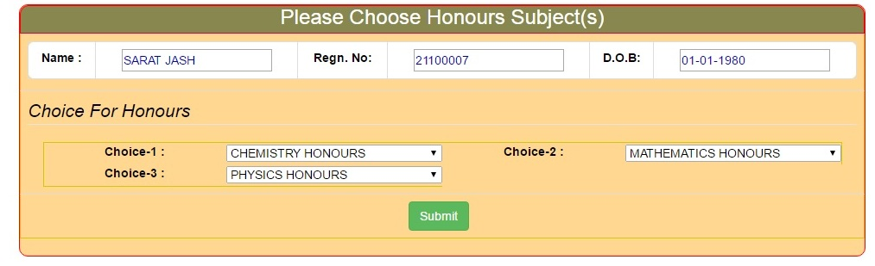
Select the Three Honours Subjects & then click Submit
Select the Three Honours Subjects & then click Submit

After submission you get a SMS indication Registration ID, User Name & Password for future login
Special Note: If you wrongly selected "Not Apply for Honours"/Not Apply for General....You never edited your form/options. You have to delete your 'application form' at student login page then apply again freshly. The deletion of your form should be done before payment of registration fee, otherwise you have to pay registration fees again without refunded the previous one.

STEP-6:
Appear the registration fee Payment options
Rs. 150/- for Honours/General Course & Rs. 250/- for Honours+General Course
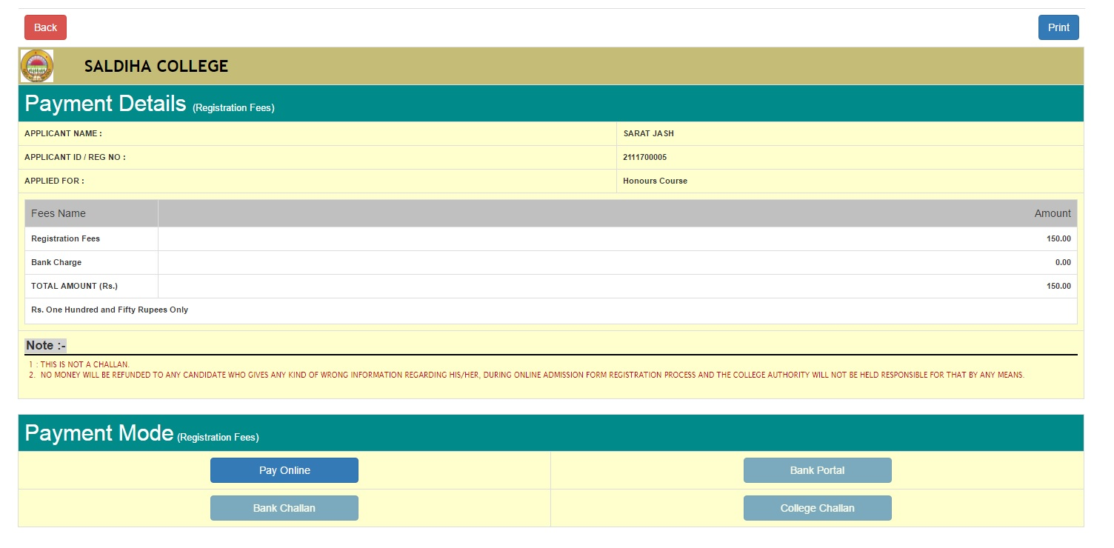
For Payment Click PAY ONLINE bottom

The registration fee & Admission fees in case of an online application may be paid by any one of the following ways:

- Candidate can make the payment online via PAY ONLINE bottom using any of the online payment mode of Debit Card/Credit Cards or Netbanking (A nominal TDR charge would be applicable). [NT: Applicants are requested to fill the require field very carefully)
Candidates would get INSTANT confirmation of their payments and submissions when they pay through online payment methods as listed.
STEP-7:

For PAY ONLINE appear the following box:

Filled-up all the information correct & carefully

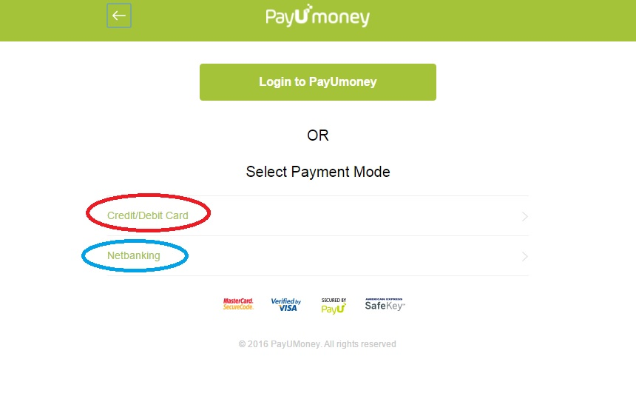
After click Credit/Debit Card appear the nest page
Choose any one of Credit/Debit Card or Net banking Payment mode

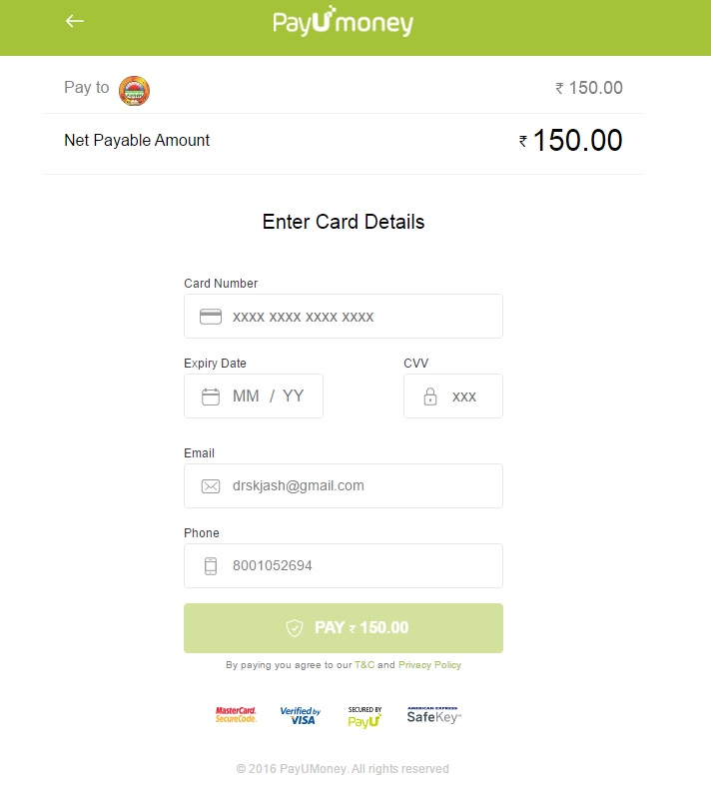
Put your Credit/Debit card information correctly
Name, Registration ID & Amount should be filled up carefully
STEP-8: Student Login

Using User Name & Password (already get via SMS)

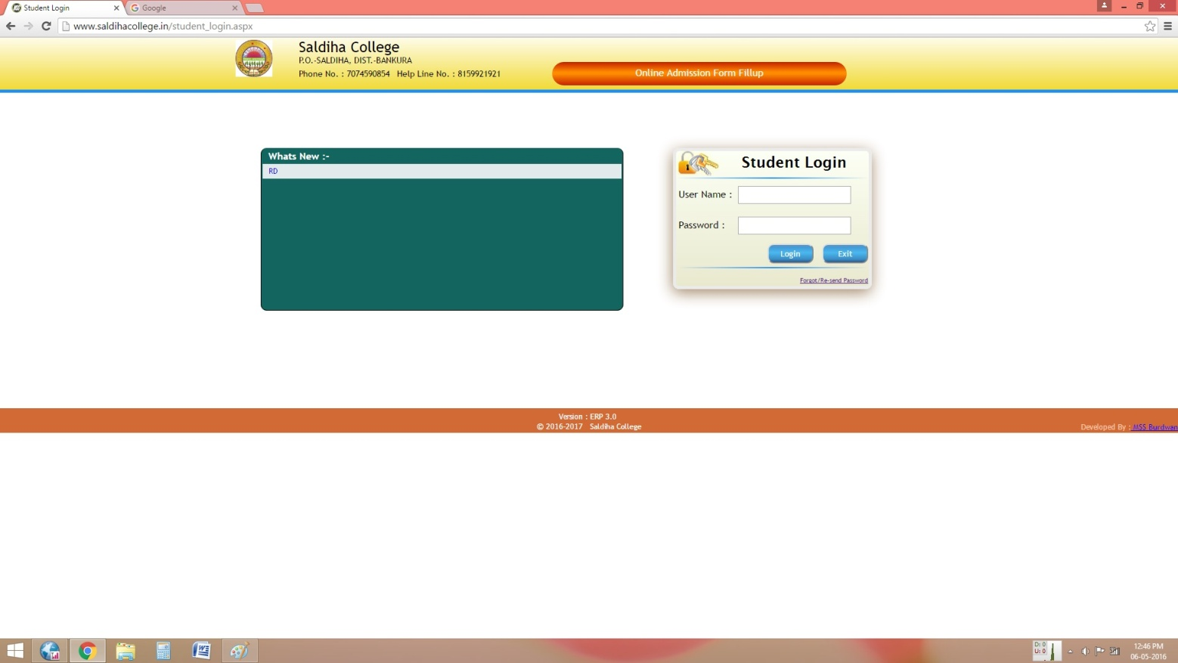
After login appear as follows
Put User Name & Password, then click login

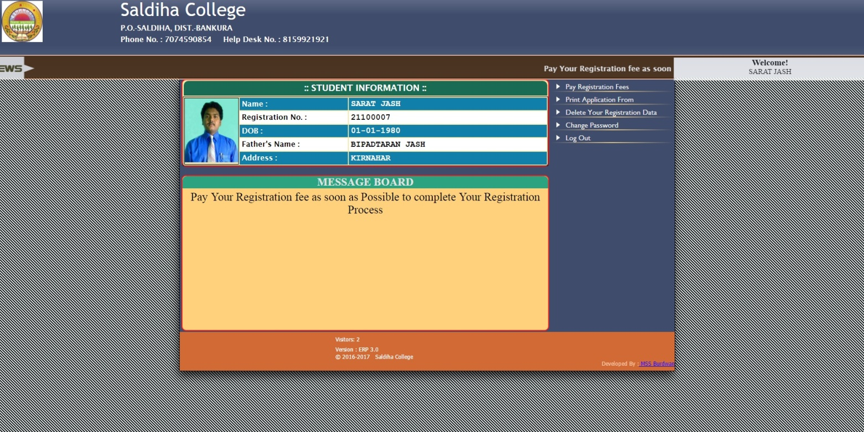
Please see the Message Board at regular intervals for Merit list or other information
Use the options as per your requirement

STEP-9: Deletion of Your Form (If applicable)

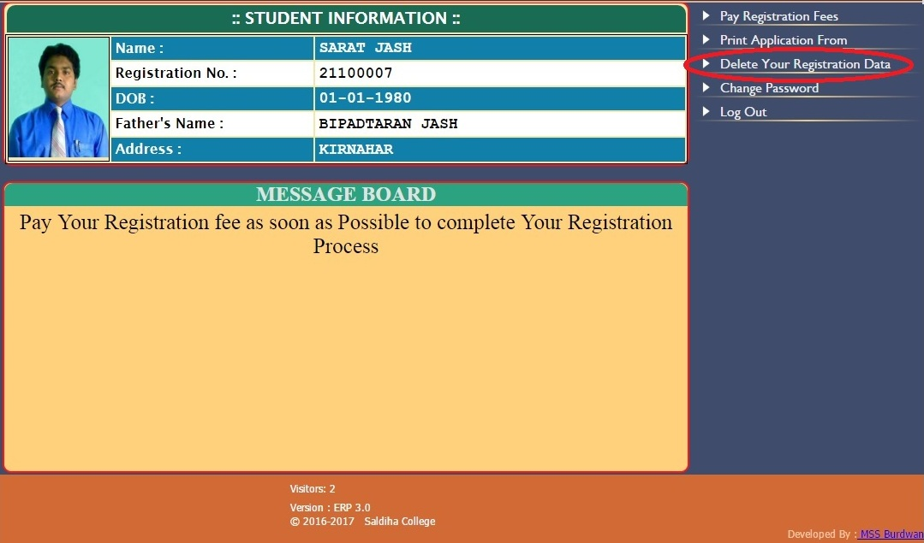
Special Note: If you wrongly selected "Not Apply for Honours"/Not Apply for General/wrong information....You never edited your form/options. You have to delete your 'application form' and then apply again freshly. The deletion of your form should be done before payment of registration fee, otherwise you have to pay registration fees again without refunded the previous one.

You can delete your data by using the red mark bottom if required. after click appear as follow......

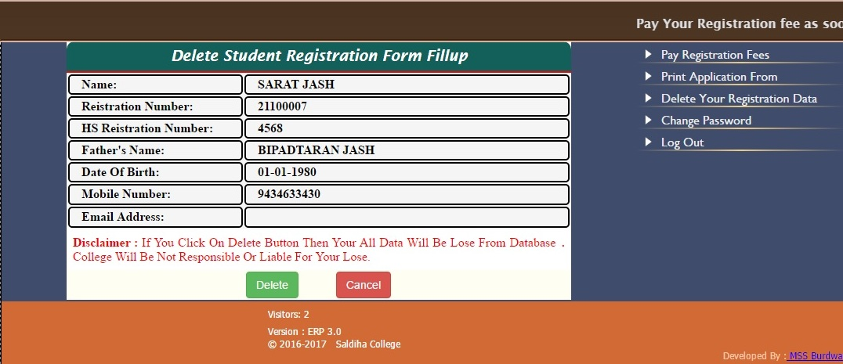
Before delete please see the message

STEP-10: Check Merit Point and Select one subject

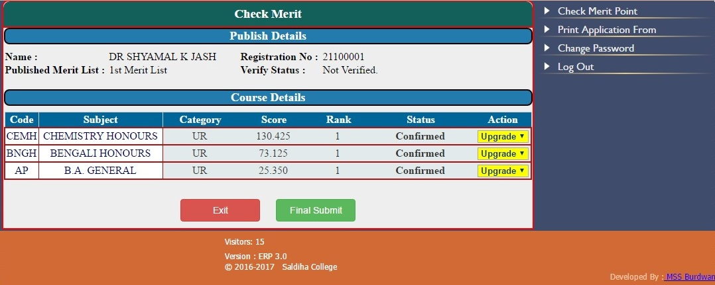
Select one subject then click Final submit

STEP-11: Choose General Subjects & pay your admission fees

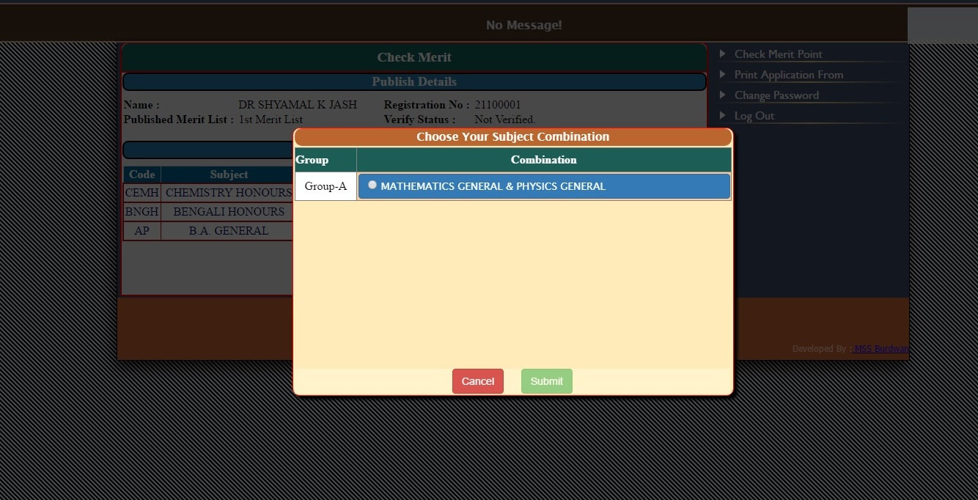
After selecting general subjects then click Submit. Pay your admission fees as per payment option and then wait for verification at college office

Help line Contact Numbers:

Please show on head of the admission website

